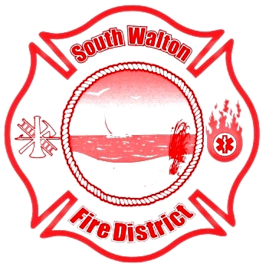
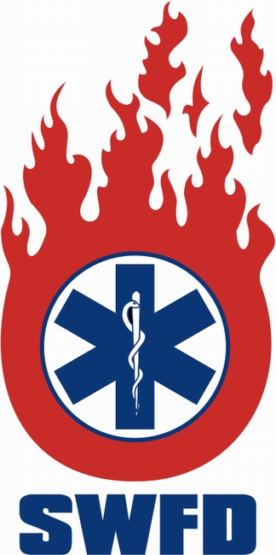
South Walton FIRE DISTRICT
911 N. County Highway 393
Santa Rosa Beach, FL 32459
(850) 267-1298 • Fax (850) 267-3294
www.swfd.org

The Board of Fire Commissioners of the South Walton Fire District will hold a Regular Meeting on November 13, 2017 at 4:00 p.m. at the Santa Rosa Beach Headquarters Station.

The agenda will include, but not be limited to the following:

- Call to Order

- Approval of Minutes
Regular Board Meeting: 10.09.2017

- Secretary/Treasurer’s Report

- Attorney’s Report

- Chief’s Report

- Committee Reports

- Unfinished/Old Business

- New Business

- Quasi-Judicial Ordinance: Final Reading
Ordinance 17-01 Gate Access
Fire Marshal Sammy Sanchez

- Public Comment*

- Adjournment

*Note: Persons who wish to be placed on the agenda must contact the Administrative Assistant within two days of any meeting and provide the name of the person who will be speaking and the subject to be addressed.

If a person decides to appeal any decision made by the Board of Fire Commissioners of the South Walton Fire District with respect to any matter considered at such meeting or hearing, he or she will need a record of the proceedings and that, for such purpose, may need to ensure that a verbatim record of the proceedings is made, which includes the testimony and evidence upon which the appeal is to be based.

